Rechenrätsel
A | B | C | H | I | K | L | M | N | O | P | R | S | T | U | .
6 | 7 | 8 | 9 | 10 | 16 | 25 | 36 | 49 | 64 | 81 | 90 | 121 | 144 | 379 | 400
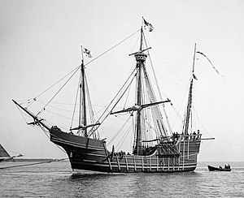
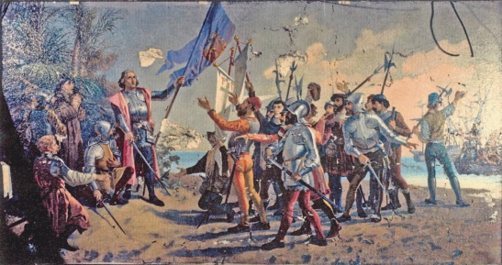
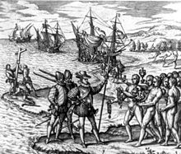

64 : 8 = |  |  | 360 : 10 = |  |  | 280 : 40 =
360 : 40 = |  |  | 420 : 60 = |  |  | 480 : 80 =
1800 : 20 = |  |  | 450 – 71 = |  |  | 630 : 70 =
100 : 10 = |  |  | 75 + 46 = |  |  | 200 : 20 =
80 + 41 = |  |  | 630 : 90 = |  |  | 11 11 =
12 12 = |  |  | 360 : 60 = |  |  | 120 – 39 =
110 – 46 = |  |  | 3 3 = |  |  | 300 : 50 =
9 9 = |  |  | 420 : 70 = |  |  | 7 7 =
810 : 90 = |  |  | 6 6 = |  |  | 500 : 50 =
4 4 = |  |  | 240 : 40 = |  |  | 8 8 =
130 – 66 = |  |  | 200 – 79 = |  |  | 100 – 75 =
5 5 = |  |  | 640 : 40 = |  |  | 180 : 30 =
500 – 121 = |  |  | 280 + 99 = |  |  | 325 + 75 =

Im Jahr 1492 entdeckte _ _ _ _ _ _ _ _ _ _ _ _ _ _ _ _ _ die _ _ _ _ _ _ _ , _ _ _ _ und _ _ _ _ _ _ _ _ _ _ (Haiti) _

