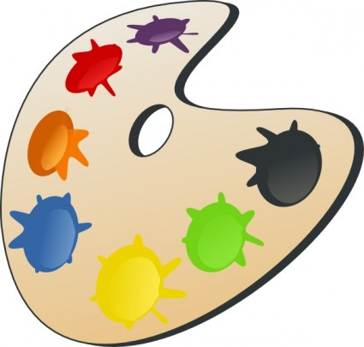

**Die Farben**

**schwarz**

(dunkel)**braun**

(hell)**braun**

(dunkel)**grün**

(hell)**grün**

(hell)**blau**

(dunkel)**blau**

**rosa, pink**

**lila**

**rot**

**orange**

**gelb**

!

**weiß**

**grau**

**Übung**



Die Banane ist gelb.



Die Zahnpasta ist blau und weiß.



________________________________________________________________



________________________________________________________________



________________________________________________________________





